Referring Physician ______________________________ Primary Care Physician _____________________________
Name________________________________________________ DOB ____/____/____ SS#_______-______-________
Address___________________________________________ City/State/Zip______________________/_____/________
Phone: Home_______________ Cell_______________ Work________________ E-mail__________________________
Occupation/Place of work_____________________________ Is injury: work / auto related? Date of Injury___/___/____
Here today because_____________________________________________________ PT treatment this year? Yes / No
I’m taking medications for_____________________________________________________________________________
Related Diagnostic Tests? X-Ray CT- Scan MRI Other____________ Where______________________________
Surgical History __________________________________________________________________ Latex Allergy? Yes / No
General Health
Do you have, or have had, any of the following?
Arthritis/Swollen Joints Y N
Cancer/Chemo/Radiation (circle) Y N
Concussion Y N
Currently Pregnant Y N
Diabetes Y N
Emotional/Psychological Problems Y N
High Blood Pressure Y N
Metal Implants Y N
Osteoporosis Y N
Seizures/Epilepsy Y N
Stroke/TIA Y N
Breathing
Snore Y N
Difficulty breathing in daily activities
i.e., going up the steps Y N
Tired after full night’s sleep Y N
Have Asthma / use inhaler (circle) Y N
Use elevated sleep position Y N
Have sleep Apnea diagnosis Y N

Neck – Jaw – Head
Facial Pain Y N
Clicking sound when open/close mouth Y N
Headache daily / weekly Y N
Dry mouth upon waking Y N
Pain in front of ear Y N
Ear fullness or ringing in the ear Y N
Tension at the base of skull with
neck turning, when upright Y N

Vision
Contacts / Glasses (circle) Y N
Bifocals / Trifocals / Invisiline (circle) Y N
Blurry vision Y N
Difficulty driving at night Y N
Feel dizzy Y N
Light sensitivity Y N
Occasionally bumping into objects Y N

Lumbo – Pelvic – Femoral
Outside of the leg & ankle strain, back or
bottom of foot (feet) tightness/pain Y N
Urine leakage when you cough, sneeze,
laugh, lift or exercise Y N
Urine leakage just before going to toilet Y N
Frequent urinating that disrupt your day Y N
Planning trips out based on where the
bathrooms are Y N
Pain, discomfort or pressure in pelvic area
when sitting or standing for prolong time Y N
Frequently straining to have a bowel
movement or to empty bladder Y N
Sensation of pressure in lower abdomen
or pelvic region Y N

Feet
Flat feet Y N
When standing pain in bottom of feet Y N
Bony bump near big toe Y N
Orthotics, heel lifts or other foot inserts Y N
One foot turns out more than other Y N
Ankle instability, one or both (circle) Y N

PLEASE INDICATE ON THE PICTURES TO THE
RIGHT THE LOCATION OF YOUR ISSUE(S)
&
PLEASE INDICATE YOUR LEVEL OF
DISCOMFORT AT ITS WORST AND BEST ON
THE SCALE BELOW
0 1 2 3 4 5 6 7 8 9 10
0 = NO DISCOMFORT 10 = EXTREME DISCOMFORT
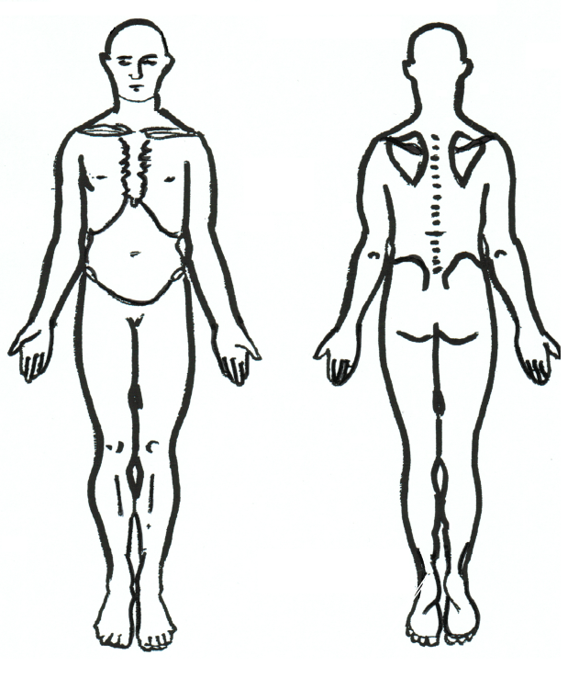
0 1 2 3 4 5 6 7 8 9 10
Please mark on the drawing to the left where you feel pain and/or discomfort.

Indicate level of your discomfort at its worst and best on the scale below
0 = No discomfort
10 = Extreme discomfort

Rate How You Function in Your Daily Activities INITIAL or FOLLOW UP (circle)

Name _______________________________________________________ DOB____/____/_______

Mild Moderate Severe Unable
Mild Moderate Severe Unable

Bending/Stooping __ __ __ __
Carrying Groceries __ __ __ __
Transferring (sit-stand) __ __ __ __
Climb Stairs __ __ __ __
Driving __ __ __ __
Extended Computer
Use __ __ __ __

Feeding (self) __ __ __ __
Household Chores __ __ __ __
Kneeling __ __ __ __
Lifting Children __ __ __ __
Lifting __ __ __ __
Pet Care __ __ __ __

Reading/concentration __ __ __ __
Self Care – Bathing __ __ __ __
Self Care – Dressing __ __ __ __
Self Care – Shaving __ __ __ __
Sexual Activities __ __ __ __
Sleep __ __ __ __
Sitting (prolonged) __ __ __ __
Standing (prolonged) __ __ __ __
Walking __ __ __ __
Yard Work __ __ __ __
Sports ____________________________________
Recreational Activities _______________________
__________________________________________

Name _______________________________________________________ DOB____/____/_______
Below are listed words that describe pain. Circle any words that describe the pain you experience.
1.
Flickering
Quivering
Pulsing
Throbbing
Beating
Pounding

2.
Jumping
Flashing
Shooting
3.
Pricking
Boring
Drilling
Stabbing

4.
Sharp
Cutting
Lacerating

5.
Pinching
Pressing
Gnawing
Cramping
Crushing
6.
Tugging
Pulling
Wrenching
7.
Hot
Burning
Scalding
Searing
8.
Tingling
Itchy
Smarting
Stinging

9.
Dull
Sore
Hurting
Aching
Heavy
10.
Tender
Taut
Rasping
Splitting
11.
Tiring
Exhausting
12.
Sickening
Suffocating

13.
Fearful
Frightful
Terrifying
14.
Punishing
Grueling
Cruel
Vicious
Killing
15.
Wretched
Blinding
16.
Annoying
Troublesome
Miserable
Intense
Unbearable

17.
Spreading
Radiating
Penetrating
Piercing

18.
Tight
Numb
Drawing
Squeezing
Tearing
19.
Cool
Cold
Freezing
20.
Nagging
Nauseating
Agonizing
Dreadful
Torturing

Medically Informed Consent and
Assignment and Release
I voluntarily consent to physical therapy treatment and services deemed necessary by my physical therapist and /or physician. I am aware that the practice of physical therapy is not an exact science and I acknowledge that no guarantees have been made to me as to the results of these services at the Comprehensive Physical Therapy. It is this clinic’s sincere intent to educate me on every process, from billing to treatment and eventually discharge from services. Therefore, if techniques that are being used to retrain, recruit & restore postural alignment are not understood, it is my responsibility to obtain a clearer understanding of what the therapist’s objectives and outcomes are, and how he/she is trying to achieve them. This consent shall be ongoing for a period not to exceed one year. During the course of treatment at the Comprehensive Physical Therapy, your therapist may recommend a procedure, materials or supplies which may be an out of pocket expense. These will be explained to you with the understanding that you may refuse or accept them. The out of pocket expenses are expected at the time of dispensing and include, but may not be limited to: Iontophoresis pads $12, Electric Stimulation pads $15, Thera-band/tubing $.50 per foot, Shoe Orthotics $300.
All materials and supply expenses will also be billed to your insurance company. If payment is received from the insurance company, a refund will be issued to the patient or applied to any outstanding balance.
I hereby authorize my insurance benefits to be paid directly to Comprehensive Physical Therapy, and understand that I am financially responsible for non-covered services. I understand that if the Comprehensive Physical Therapy is out of network with my insurance company; I will be responsible for the difference between what is charged and what my insurance pays. I also authorize Comprehensive Physical Therapy to release any information necessary in order to process this claim. All of the information I have provided is correct and true to the best of my knowledge. I am responsible for all charges incurred at Comprehensive Physical Therapy.
I, ______________________________ have read this form, and fully understand and accept its terms and conditions.
___________________________________________________ _____________________________
If not a patient, state patient name Date / Time

_________________________________________ __________________________________
Indicate relationship to patient Witness signature at time of signing

Acknowledgement of Receipt of Privacy Practices Notice
Comprehensive Physical Therapy,Inc., Kathy Michaels, Office Administrator
I hereby acknowledge that I have received a copy of the
Comprehensive Physical Therapy Notice of Privacy Practices. I agree to be contacted via:
Signature: ______________________________________________ Cell phone: _______________________________
Print Name: _____________________________________________ Telephone: _______________________________
Date: __________________________________________________ E-mail: ___________________________________

Authorization for the release and use of photograph and/or video to
The Physical Therapy Center of Horseheads

I authorize and permit the Comprehensive Physical Therapy to:
Photograph and/or video me while I am receiving physical therapy for the purpose of;
- Establishing a home exercise program, supplied to me via media outlet
- For limited research and educational purposes

My e-mail address is_________________________________

______________________________ ________________
Signature of Client (Parent/Guardian if under age 18) Today’s Date

______________________________
Print Name of Client

Comprehensive Physical Therapy, Inc
A Restorative Physical Therapy Practice
Summary of Privacy Practices
This summary is provided to assist you in understanding our office’s complete NOTICE OF PRIVACY PRACTICES
Our complete Notice of Privacy Practices contains a detailed description of how our office will protect your health information, your rights as a patient and our common practices in dealing with patient health information. Please refer to that Notice for further information which is located in our office.
Uses and Disclosures of Health Information We will use and disclose your health information in order to treat you or to assist other health care providers in treating you. We will also use and disclose your health information in order to obtain payment for our services or to allow insurance companies to process insurance claims for services rendered to you by us or other health care providers. Finally, we may disclose your health information for certain limited operational activities such as quality assessment, licensing, accreditation and training students.
Uses and Disclosures Based on Your Authorization We will not use or disclose your health information without your written authorization, except as stated in more detail in the Notice of Privacy Practices.
Uses and Disclosures Not Requiring Your Authorization In the following circumstances, we may disclose your health information without your written authorization:
- For limited research and educational purposes
- For purposes of public health and safety
- To government agencies for purposes of their audits, investigations & other oversight activities
- To government authorities to prevent child abuse or domestic violence
- To the FDA to report product defects or incidents
- To law enforcement authorities to protect public safety or to assist in apprehending criminal offenders
- When required by court orders, search warrants, subpoenas & as otherwise required by law

Patient Rights As our patient, you have the following rights:
- To have access to and/or a copy of your health information
- To receive an accounting of certain disclosures we have made of your health information
- To request restrictions as to how your health information is used or disclosed
- To request that we communicate with you in confidence
- To request that we amend your health information
- To receive notices of our privacy practices

If you have a question, concern or complaint regarding our privacy practices, please refer to our complete Notice of Privacy Practices.

